Ryder Brow Community Allotment Society's post

A wonderful pumpkin... - Ryder Brow Community Allotment Society | Facebook

A wonderful pumpkin celebration event! Thanks everyone !

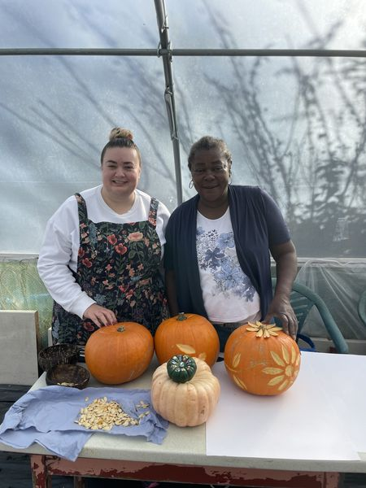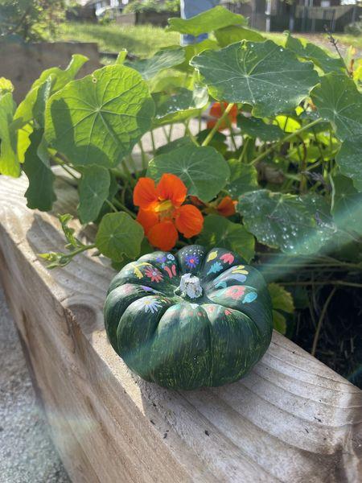

Greater Manchester Environment Fund
31 October at 11:55 ·
Happy Halloween! Our Grants Assistant Danielle recently attended a Pumpkin Celebration event at Ryder Brow Community Allotment Society - look at that beautiful pumpkin she painted!
Danielle said: "It was great to meet the members of Ryder Brow Community Allotment Society. Marva and Rachel gave engaging demonstrations of how to use every part of a pumpkin and how to begin your own compost bin. It was clear how much hard work the volunteers have put into taking ownership of the allotments and the Pocket Park to make it a bright, attractive and safe space for the community."
Hope you all have a spook-tacular day
#Halloween2024 #GreenSpacesFund

